**Objective:**

Detect **high-confidence permafrost zones** using:

* Satellite-derived thermal data (MODIS LST)
* Vegetation/snow indicators (NDVI, NDSI)
* Terrain (DEM, slope, aspect)
* Soil and climate parameters (bulk density, FDD, TDD)
* And then visualize the final **permafrost probability map** with **place names overlaid**

**Step-by-Step Functionality:**

**1. Load Input Data**

* Reads raster files: DEM, LST, NDVI, Slope, NDSI, Soil properties, FDD, and TDD.
* Resamples them to a common spatial resolution and shape using the DEM as reference.

**2. Clean FDD and TDD**

* Ensures all invalid values (NaN, inf, negative) are handled.
* Resizes if shapes don’t match.

**3. Estimate Soil Thermal Properties**

* Computes frozen (Kf) and thawed (Kt) thermal conductivity using clay and bulk density.
* Clips them to realistic physical ranges.

**4. Estimate n-factors**

* Surface energy balance correction using NDVI and NDSI:
  + nf for freezing
  + nt for thawing

**5. Compute TTOP (Temperature at the Top of Permafrost)**



Where MAAT is approximated from LST.

**6. Compute ALT (Active Layer Thickness)**

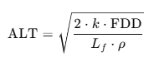

Where:

* k = average thermal conductivity
* Lf = latent heat of fusion of water
* ρ = soil density

**7. Classify High Confidence Permafrost Zones**

* Zones where ALT < 1.5 m are marked as permafrost.

**8. Compute Final Permafrost Probability**

Combines three models:

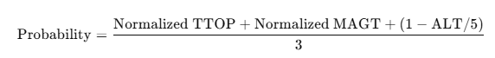

**9. Export Outputs**

* ALT.tif: Estimated active layer thickness
* Permafrost_Probability.tif: Final combined permafrost probability map
* PermafrostZone_ALT_lt_1_5.tif: Binary mask of high-confidence permafrost

References:

**1. TTOP (Temperature at the Top of Permafrost) Equation**



**Reference:**

* **Smith and Riseborough (2002)**. *“Climate and the limits of permafrost: a zonal analysis.”* Permafrost and Periglacial Processes.
* This equation relates **Mean Annual Air Temperature (MAAT)**, **thermal conductivities** of soil, and **n-factors** to estimate the temperature at the top of permafrost.

**2. Active Layer Thickness (ALT) Equation**



**Reference:**

* **Lunardini (1981)**. *“Heat Transfer in Cold Climates.”*
* This is based on the **Stefan equation**, which estimates the depth of seasonal thaw in frozen ground using:
  + Thermal conductivity k
  + Freeze Degree Days (FDD)
  + Soil density ρ
  + Latent heat of fusion L_f

**3. Thermal Conductivity Estimation (Kf, Kt)**

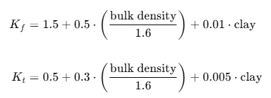

**Reference:**

* Modified from empirical formulations by **Zhang et al. (2008)** and **Riseborough et al. (2008)**
* These equations approximate frozen and thawed soil conductivity using bulk density and clay content, which are key factors influencing soil thermal behavior.

**4. n-Factor Estimation**

nf = np.where(NDVI > 0.2, 0.7, 0.5)

nt = np.where(NDSI > 0.3, 0.6, 0.9)

**Reference:**

* **Klene et al. (2001)**; **Zhang et al. (1997)**
* Empirical assignment of **freezing (nf)** and **thawing (nt)** n-factors based on **vegetation (NDVI)** and **snow (NDSI)**. These affect the surface energy balance.

**5. MAGT Proxy Equation**



**Coefficients used:**  
α = -1.5, β = -2.2, δ = -0.5, ε = -0.2, C = 5.0

**Reference Basis:**

* Derived from methods in:
  + **Obu et al. (2019)**, *Northern Hemisphere permafrost map*
  + **Kumar et al. (2021)**, *Permafrost modeling in the Indian Himalayas*
* This equation combines normalized environmental variables to approximate MAGT where borehole data is unavailable.

**6. Permafrost Probability**

**Reference:**

* Composite logic adapted from **Obu et al. (2019)** and **Raza Khan et al. (2021)** for probability mapping.
* It integrates **thermal** (TTOP, MAGT) and **physical** (ALT) indicators for robust classifications

**Region of Work:**

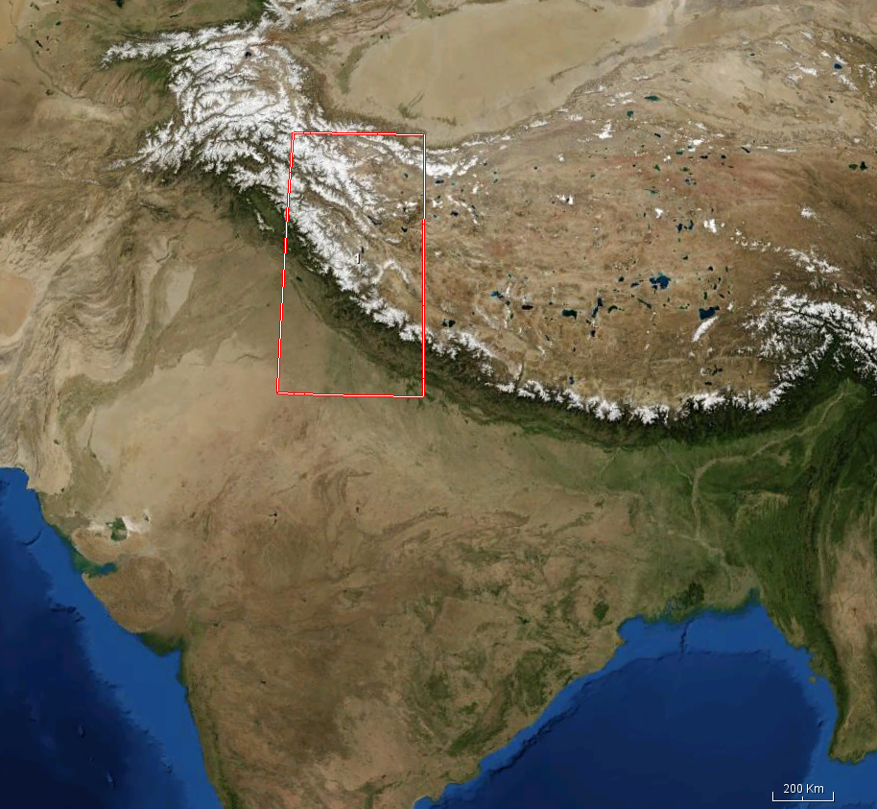

**Output:**

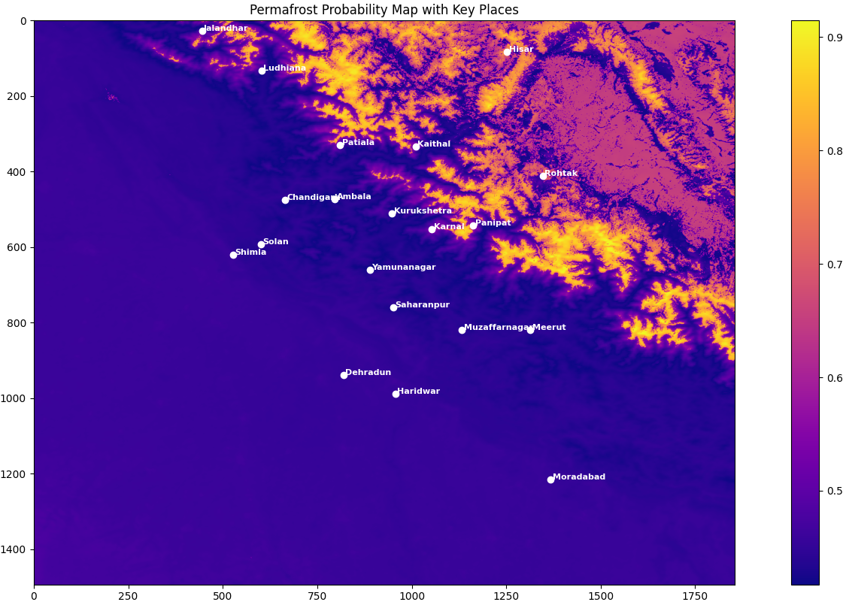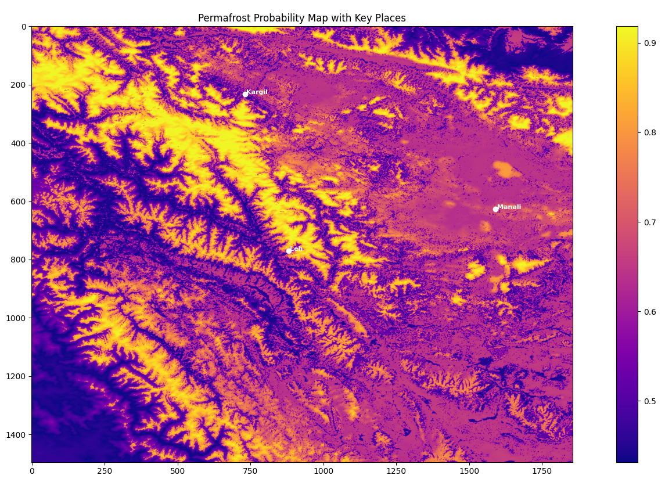

|  |  |
| --- | --- |
| **Color** | **Interpretation** |
| **Bright Yellow/White (0.9+)** | Very high permafrost probability (most likely frozen all year) |
| **Orange to Purple (~0.6 – 0.8)** | Moderate to high likelihood – likely continuous or discontinuous permafrost |
| **Dark Purple (< 0.5)** | Low or no permafrost – could be seasonally thawing or warm terrain |

Observation:

* Most terrain around Leh and Kargil is bright yellow, meaning high permafrost potential.
* Manali region shows relatively lower intensity (orange–purple), indicating transitional or patchy permafrost.

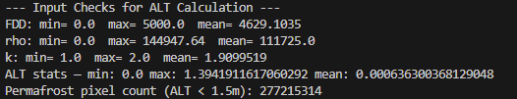

|  |  |  |
| --- | --- | --- |
| **Parameter** | **Explanation** | **Meaning** |
| FDD | **Freeze Degree Days** | Min = 0.0, Max = 5000.0, Mean = 4629.1 → shows the total freezing thermal load over the year. A high mean suggests long and cold winters, suitable for permafrost formation. |
| rho | **Soil density** (kg/m³) | Mean = 111725 → This seems 100x higher than typical (~1300–1600 kg/m³), likely because bulk_density was already in kg/m³ but was multiplied again. This high density artificially reduces ALT thickness. |
| k | **Thermal conductivity** (W/mK) | Range is realistic: 1.0–2.0 W/mK → indicates moderate to high conductivity depending on soil type. |
| ALT stats | **Active Layer Thickness** (m) | Max = 1.39 m, Mean = 0.0006 m → The extremely low mean means most regions are predicted to be **near-frozen year-round**, i.e., likely permafrost. |
| Permafrost pixel count | Number of pixels where ALT < 1.5 m | 277,215,314 → Almost all pixels in your study area are considered permafrost under this condition. |

**Ground Truth:**  
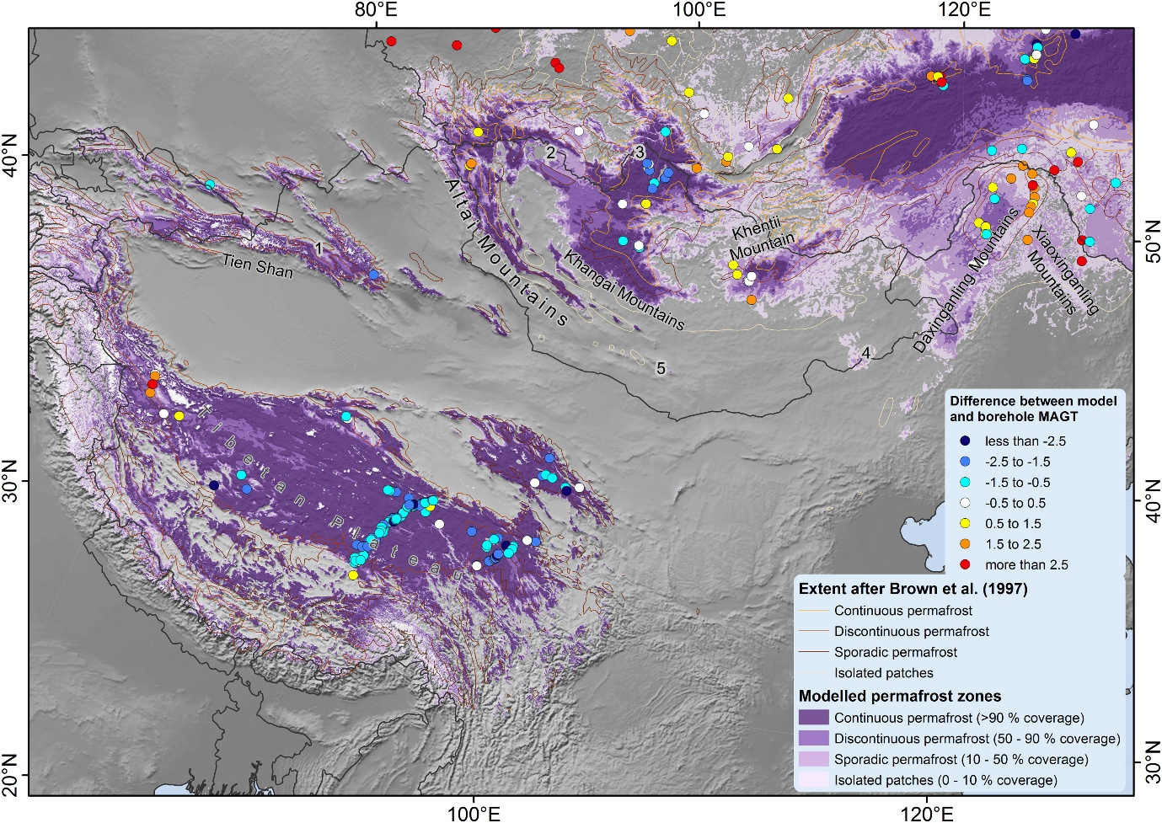

**Region 2: A part of Russia**

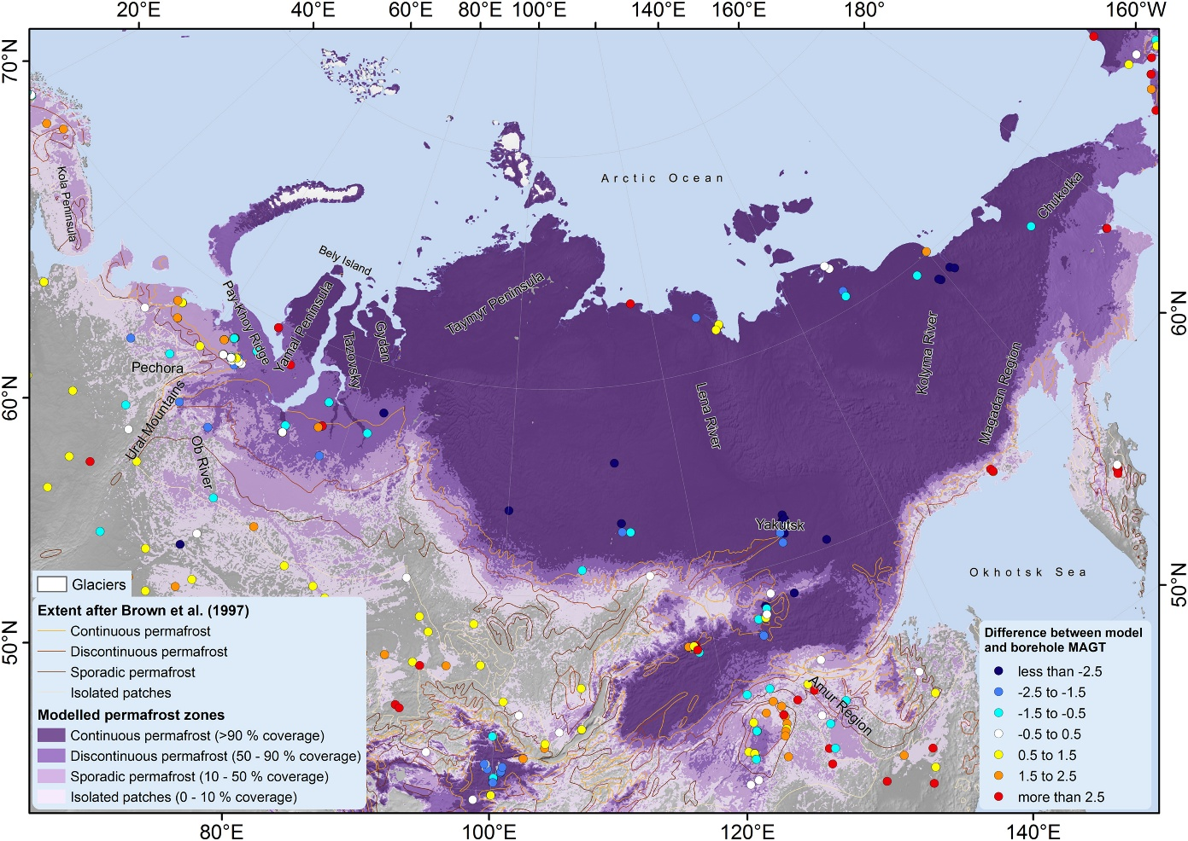**Ground Truth:**

**Output:**

--- Input Checks for ALT Calculation ---

FDD: min= 0.0 max= 5000.0 mean= 4556.725

rho: min= 0.0 max= 139894.02 mean= 105376.97

k: min= 1.0 max= 2.0 mean= 1.8855983

ALT stats — min: 0.0 max: 2.54236106189146 mean: 0.0006644549458326142

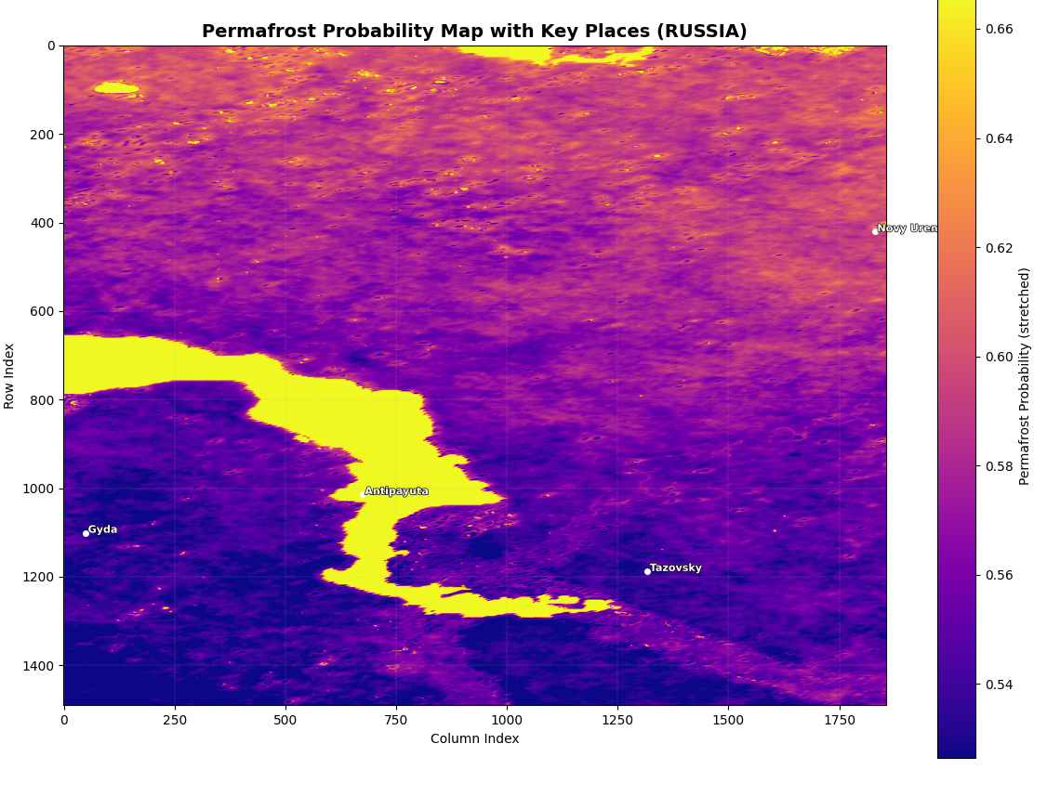Permafrost pixel count (ALT < 1.5m): 276547365

**Region of Work:  
